OOPM ASSIGNMENT

Name: Shreyas Sawant Class: D7A Roll No. 55

Q.1 Write a program to calculate the total surface area and volume of the cylinder . Make use of keyword final.

CODE:

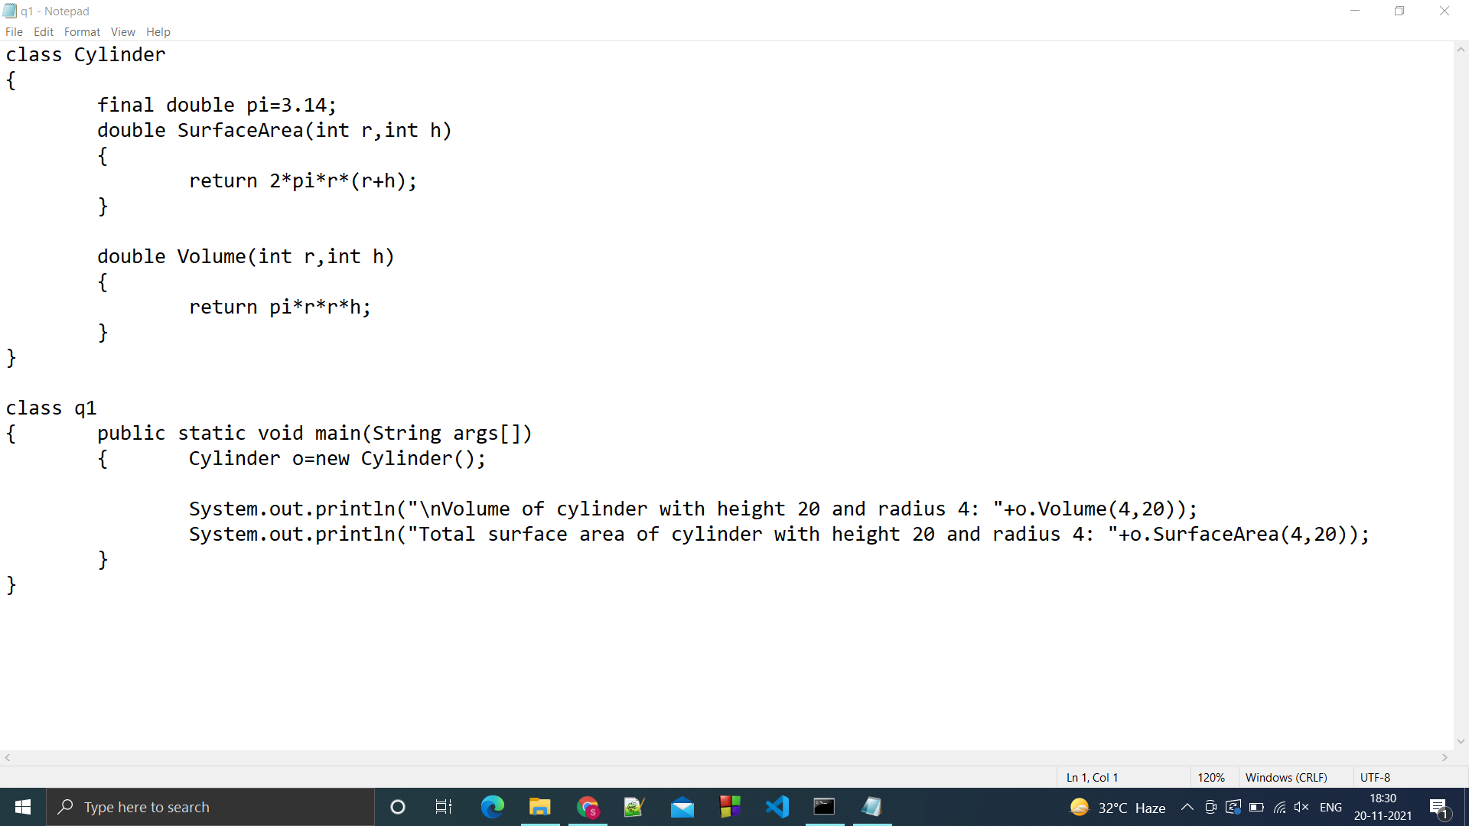

OUTPUT:

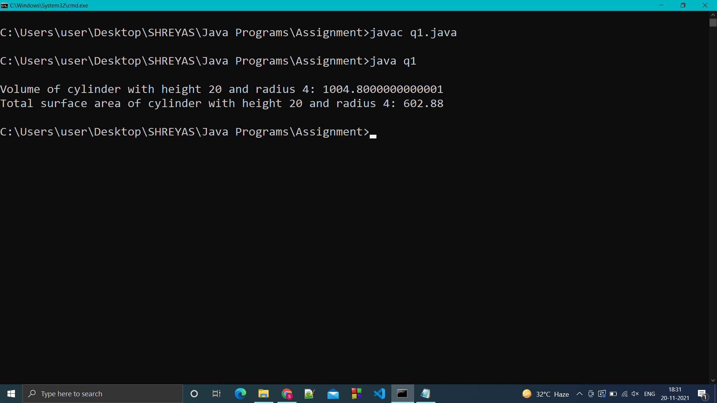

Q.2 Write a program to calculate the hypotenuse of a right angled triangle when other sides of the triangle are given.

CODE:

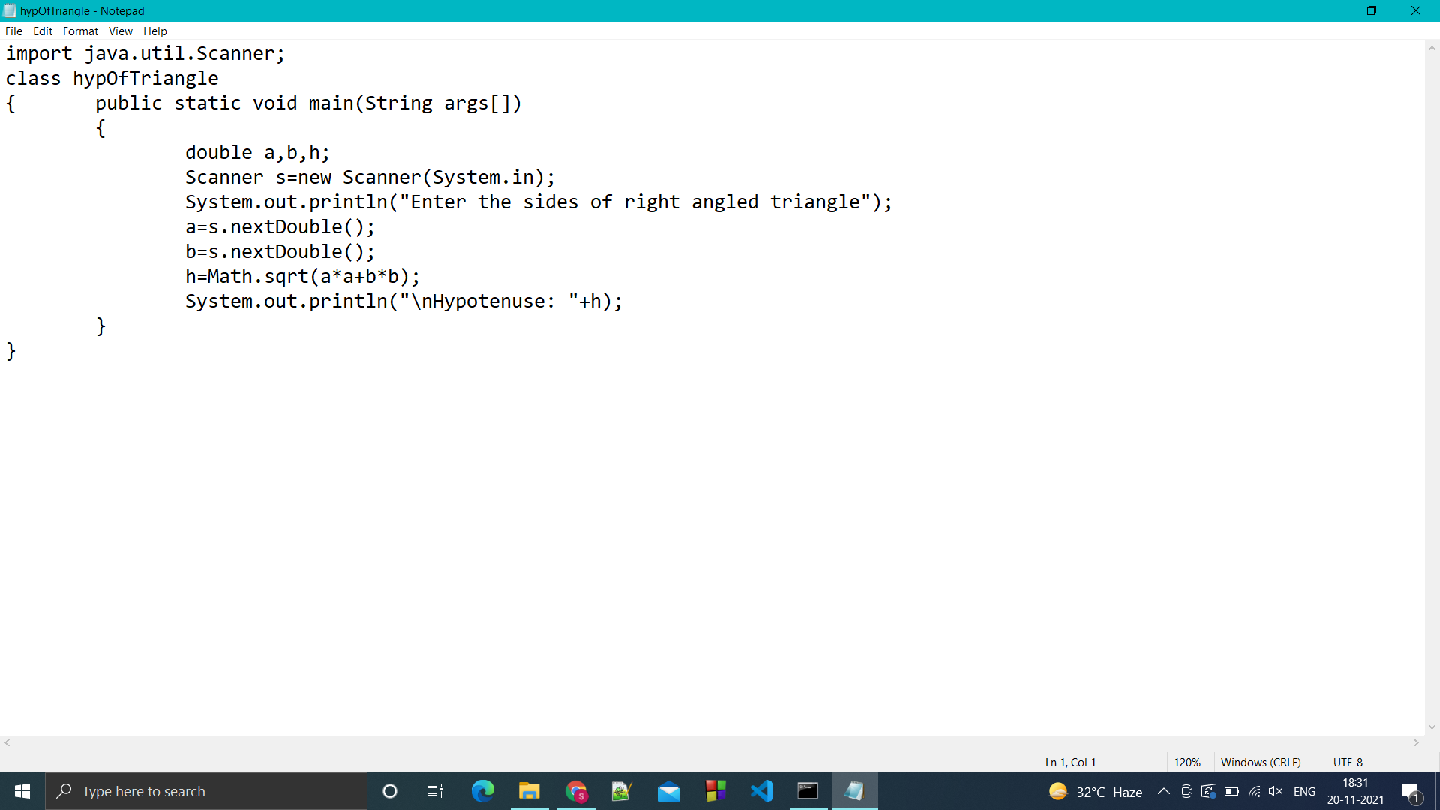

OUTPUT:

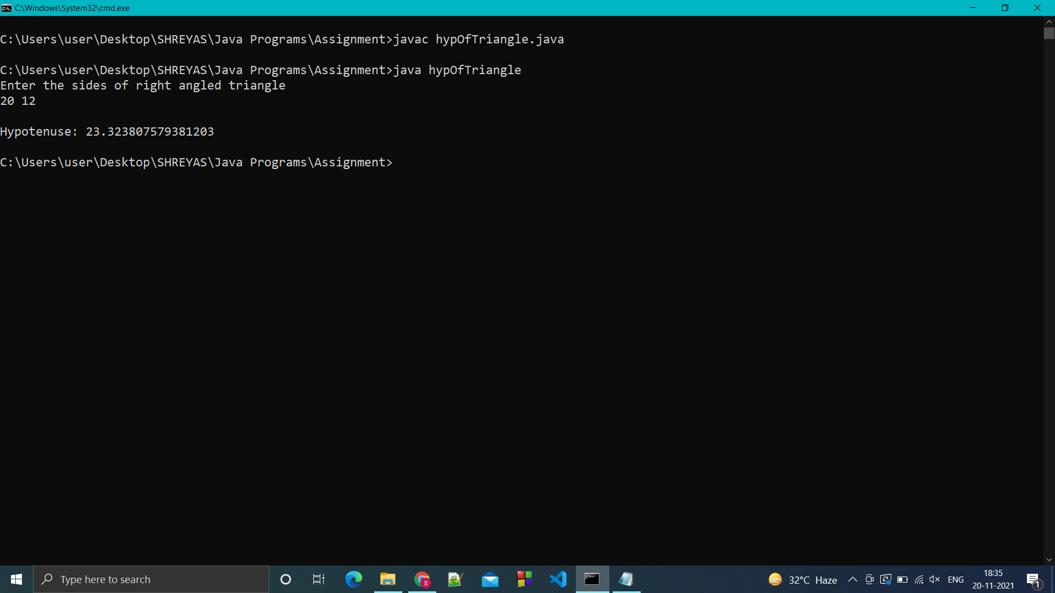

Q.3 Write a program to print first n even and odd nos. take the value of n from the keyboard via command line argument.

CODE:

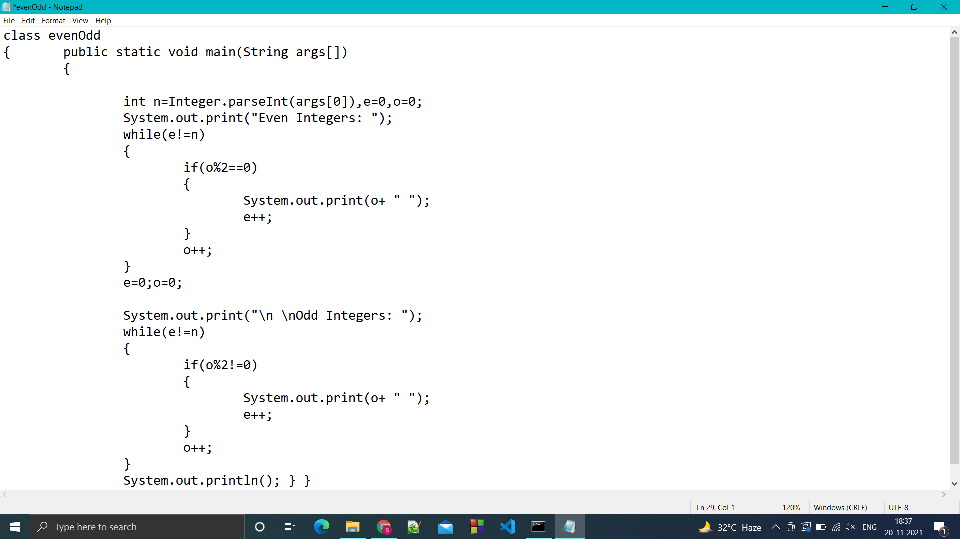

OUTPUT:

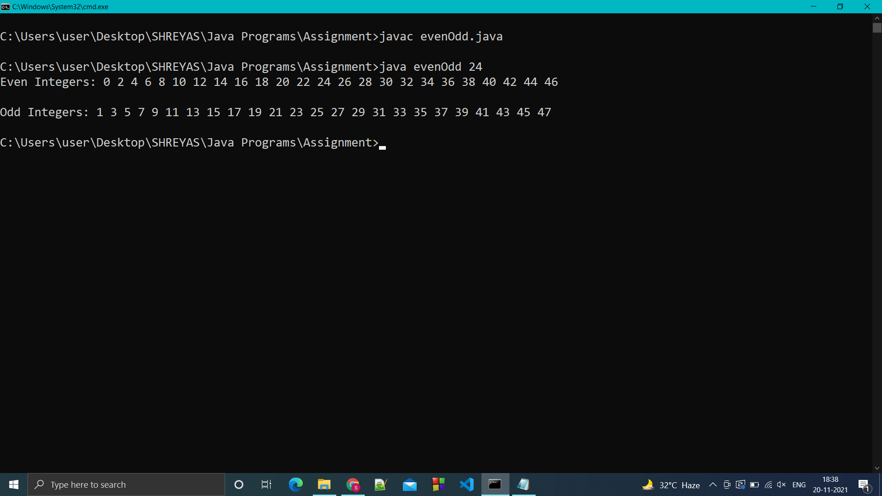

Q.4 Write a program to print the spiral Matrix of order 5:

CODE:

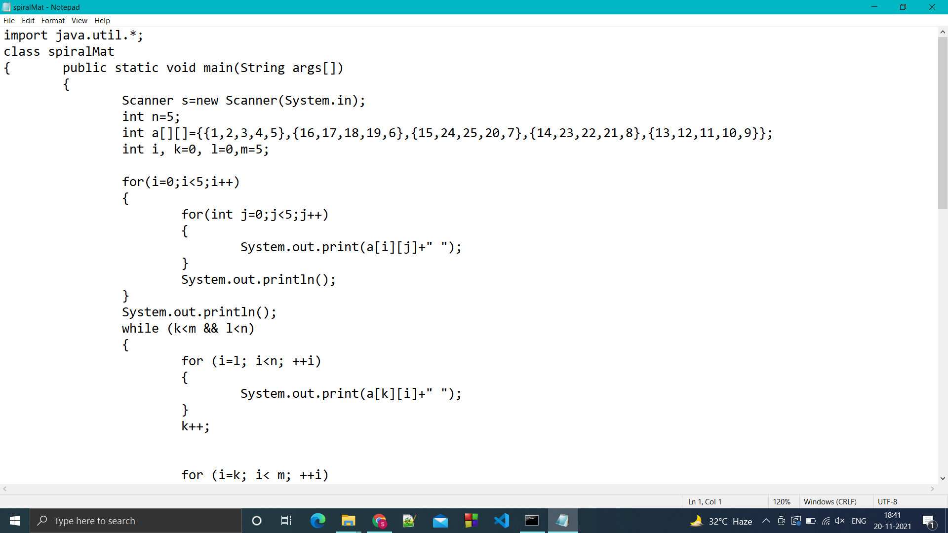

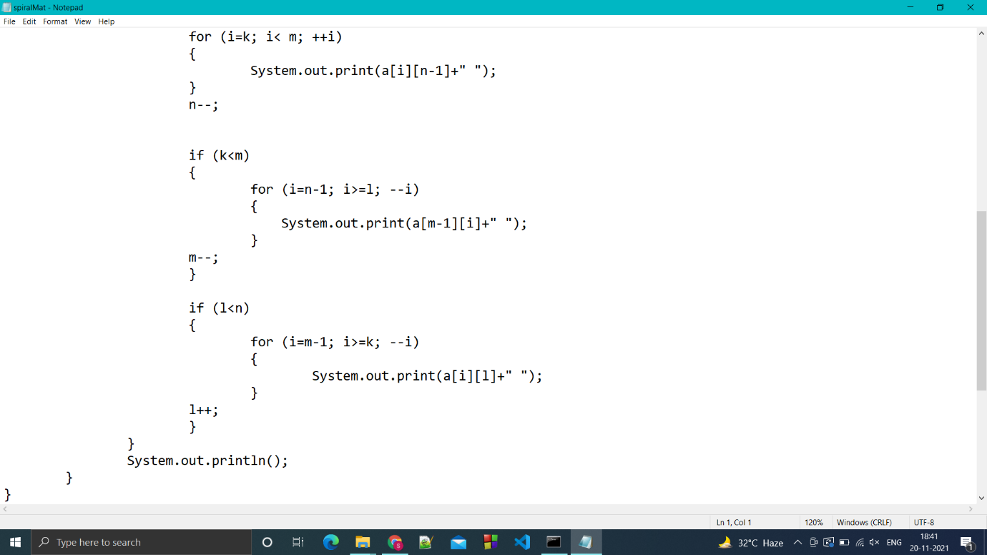

OUTPUT:

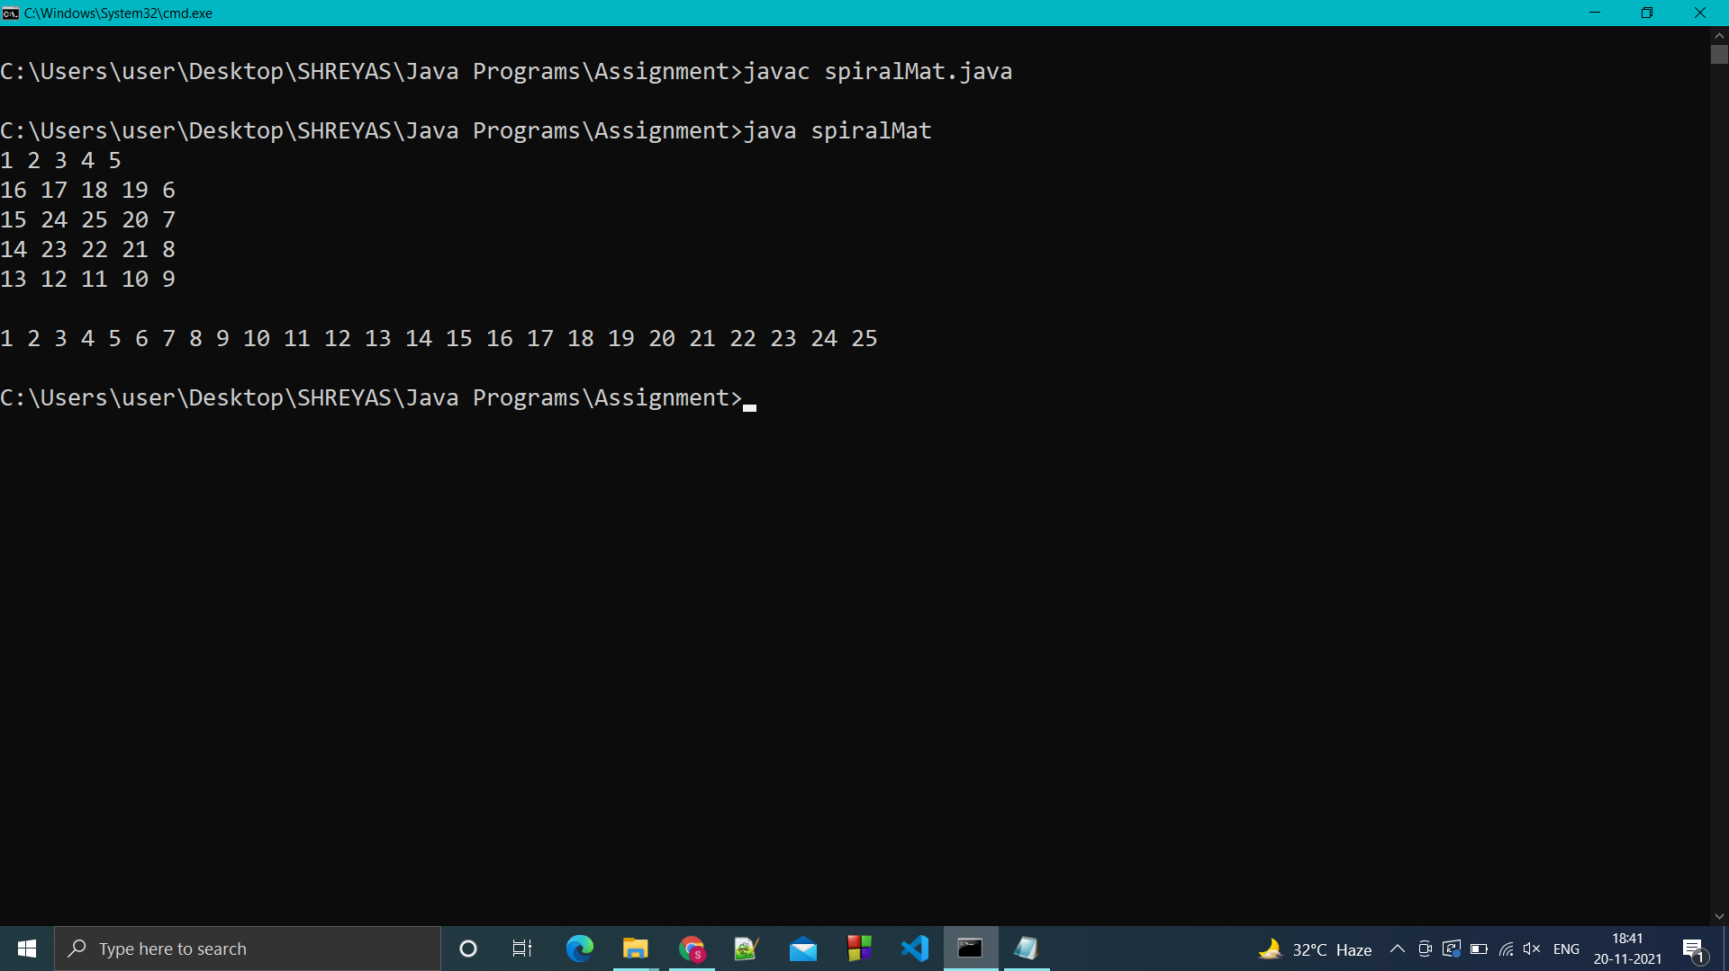

Q.5 Write a program to find sum and average of numbers on even and odd indexes in the array entered by the user.

CODE:

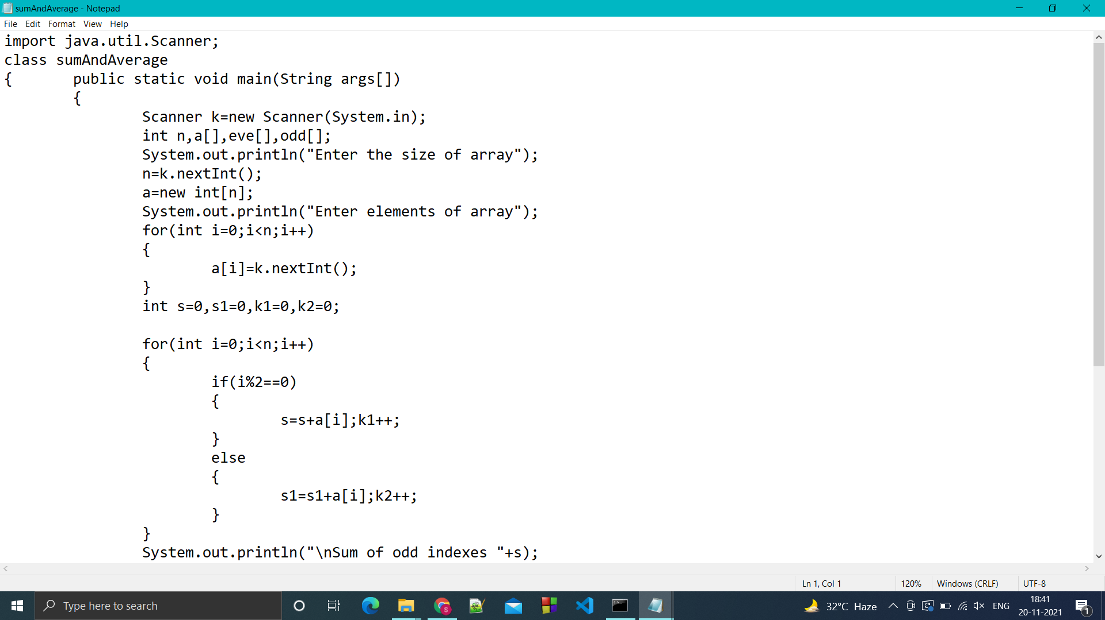

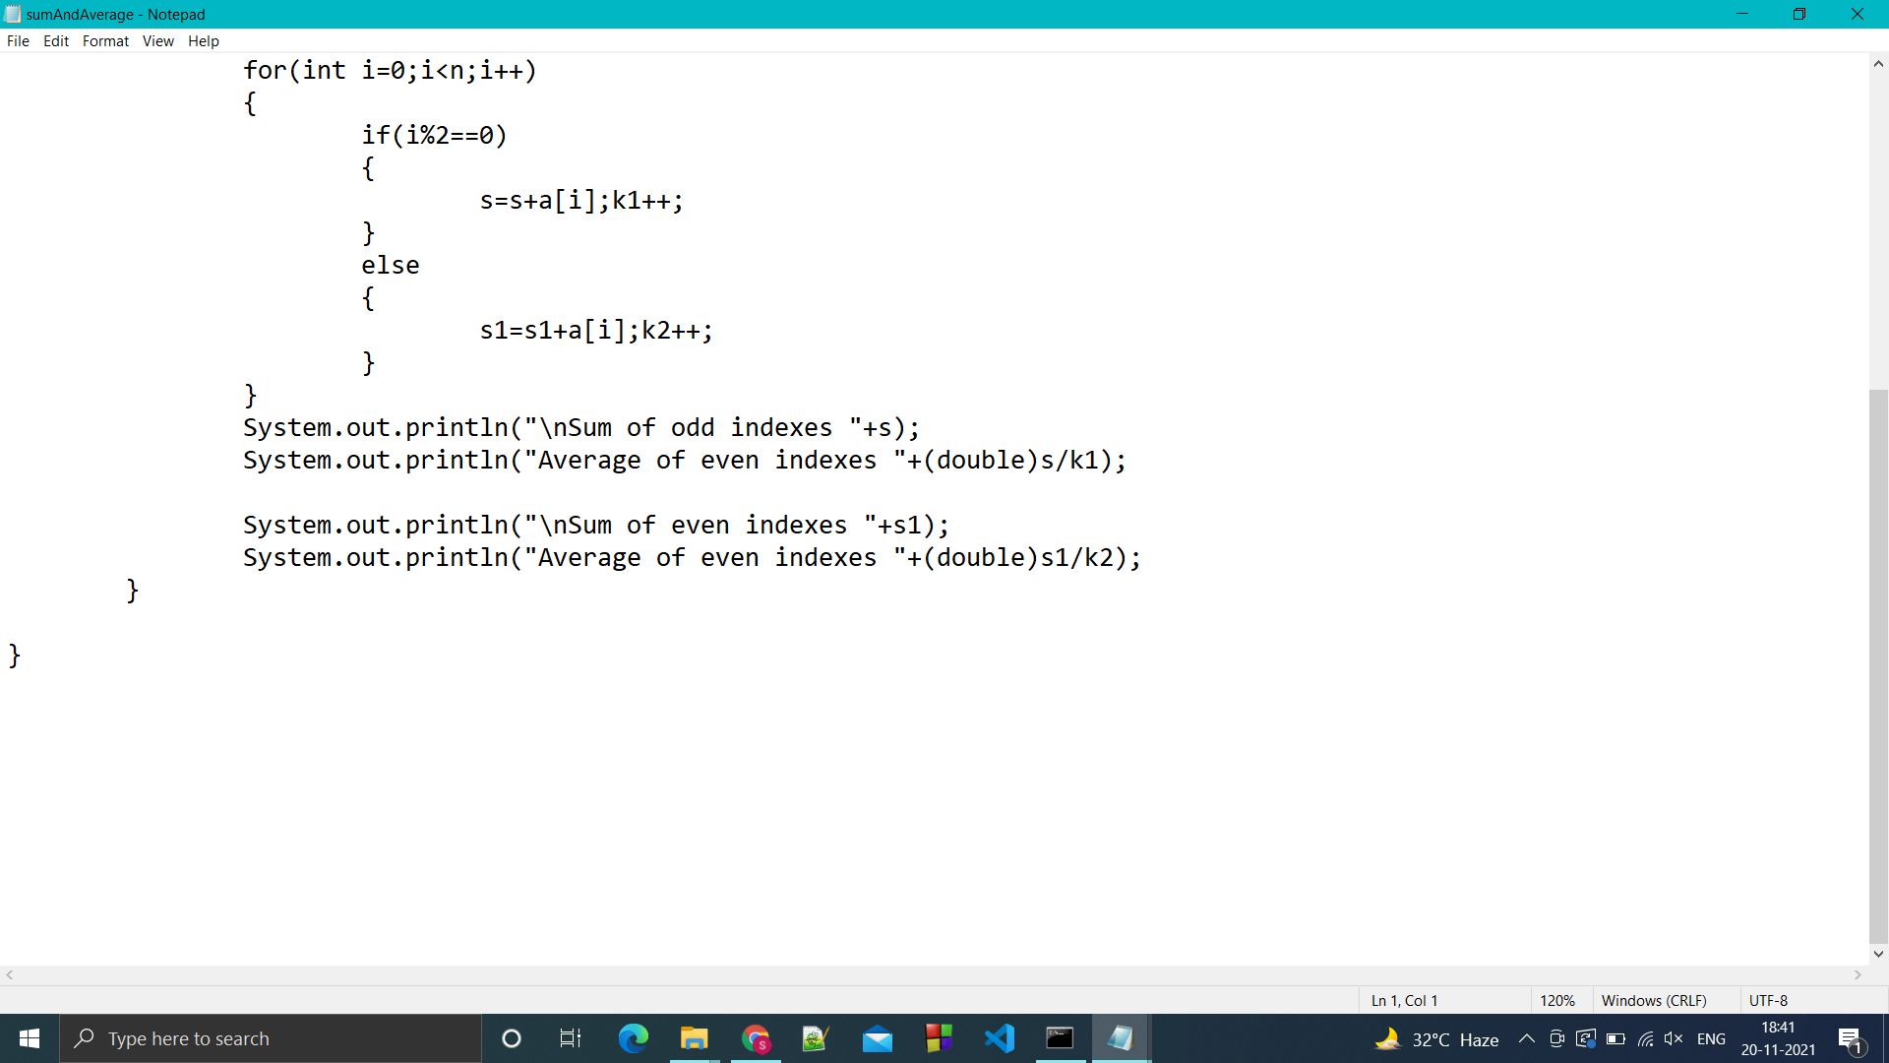

OUTPUT

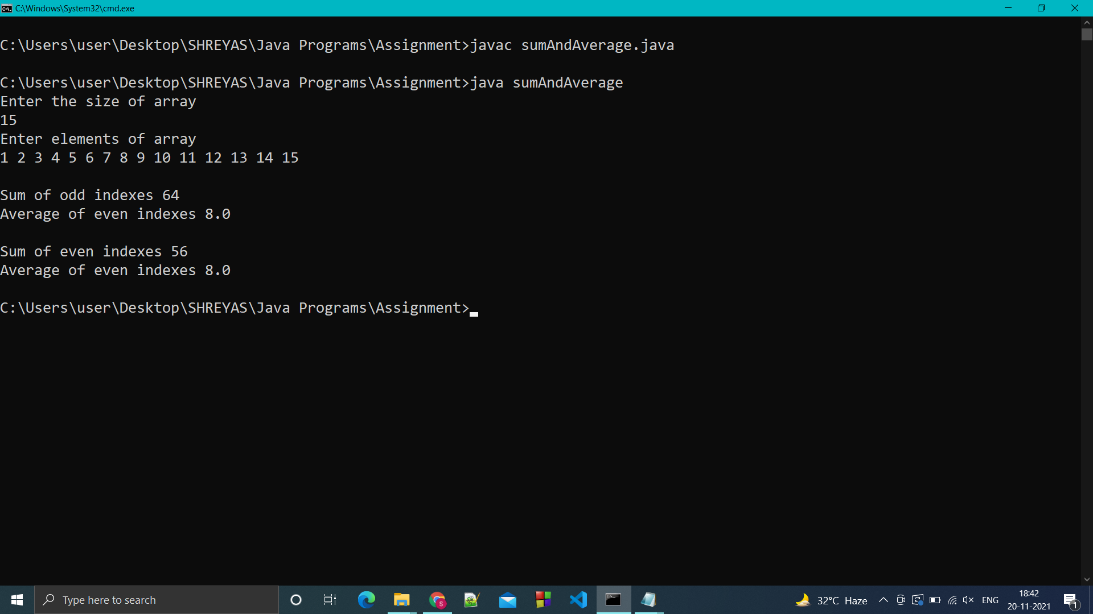

Q.6 Write a pogram to sort the list of students on the basis of their marks.

CODE:

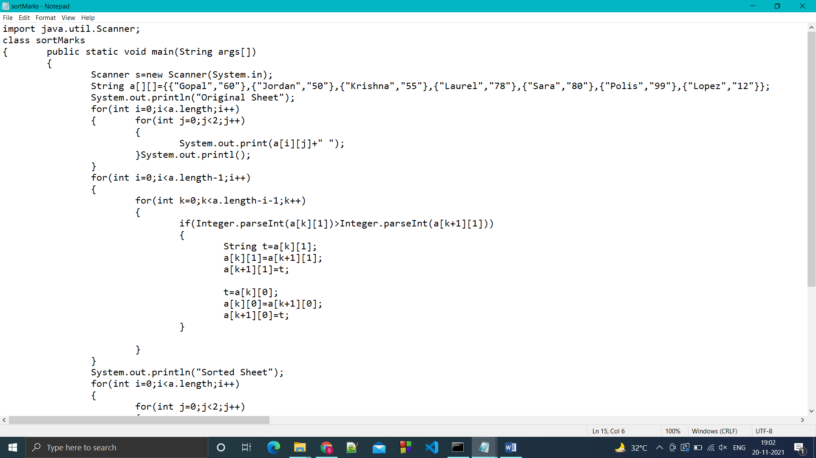

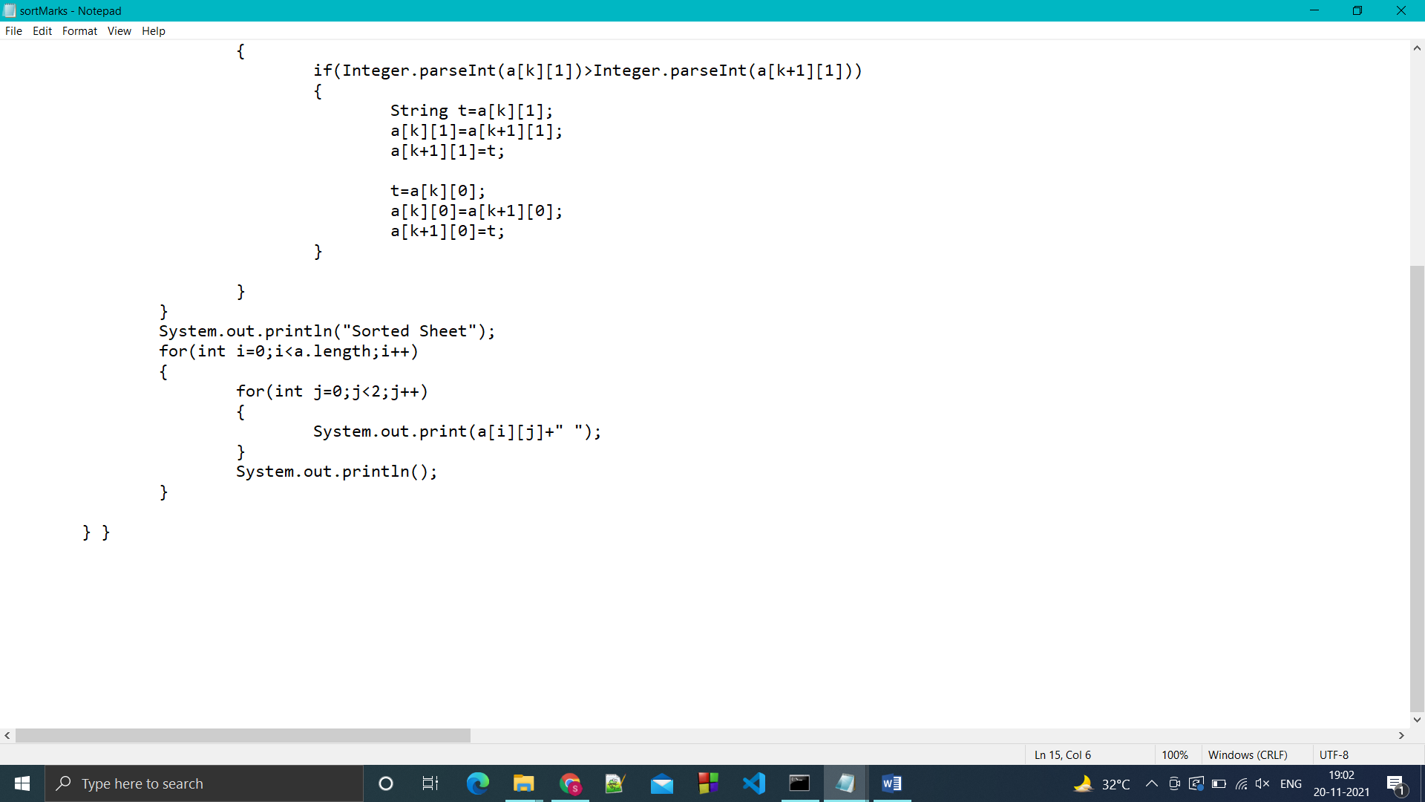

OUTPUT:

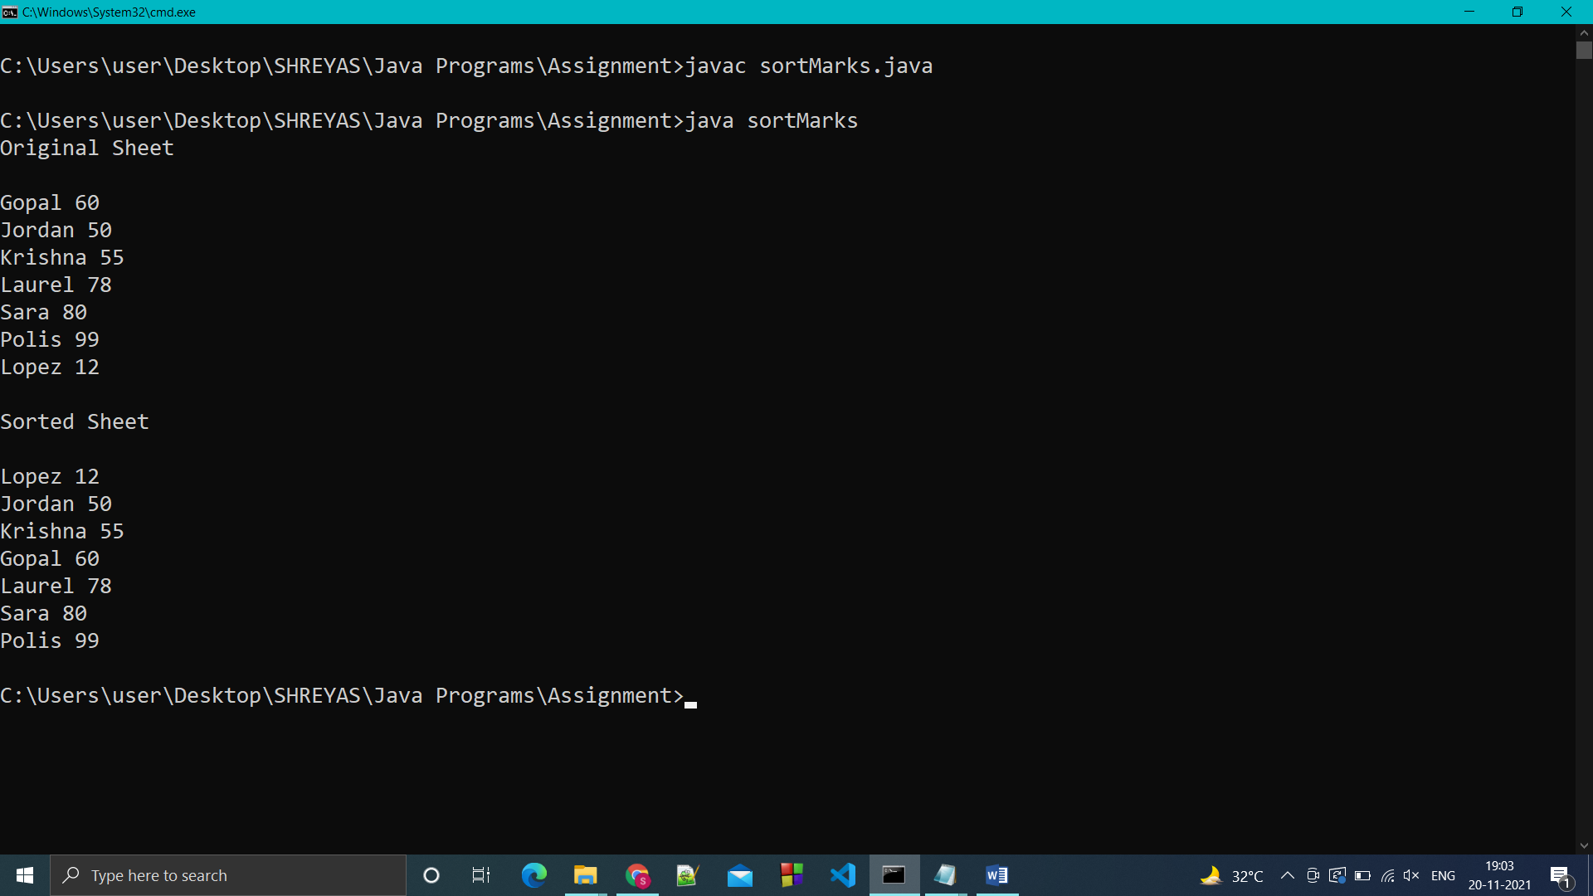

Q.7 Write a program to create a long string and replace all the occurrence of 'an' with 'the'.

CODE:

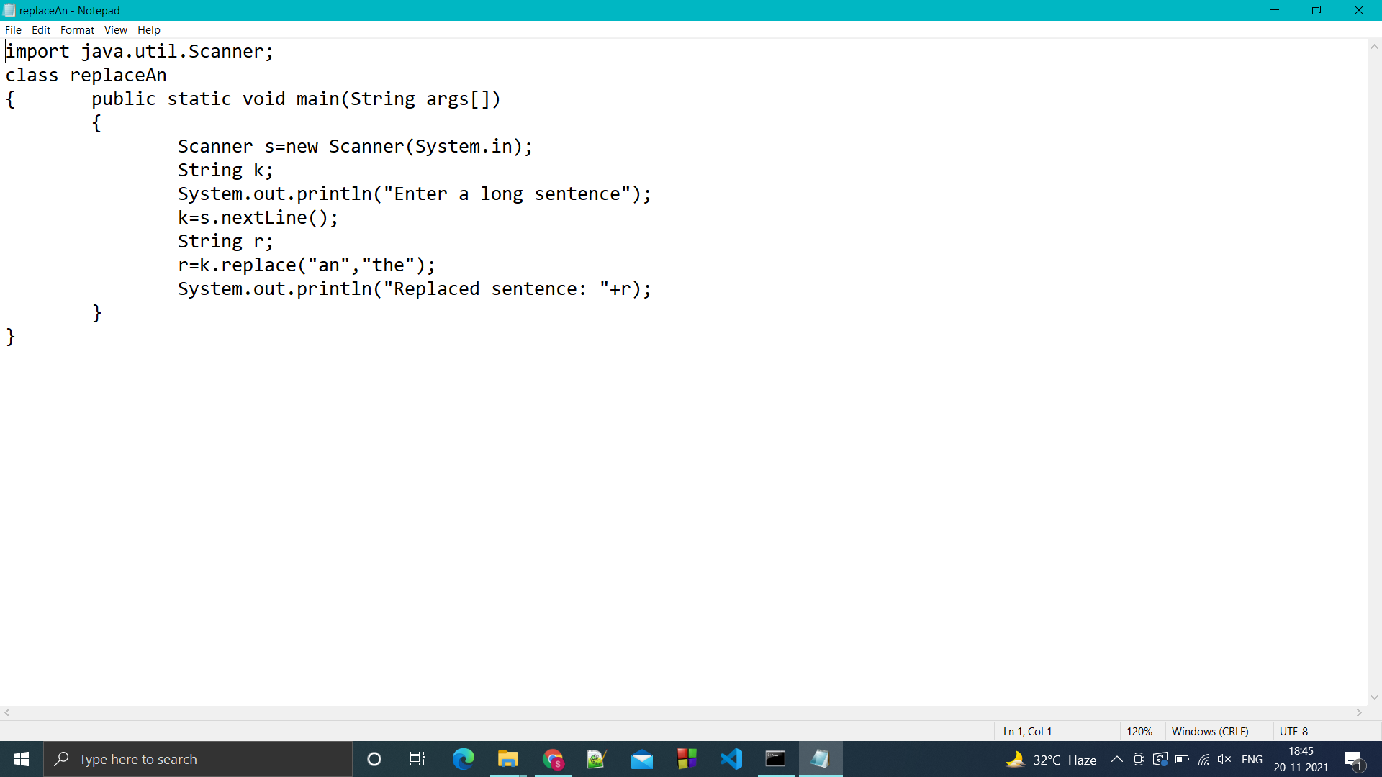

OUTPUT:

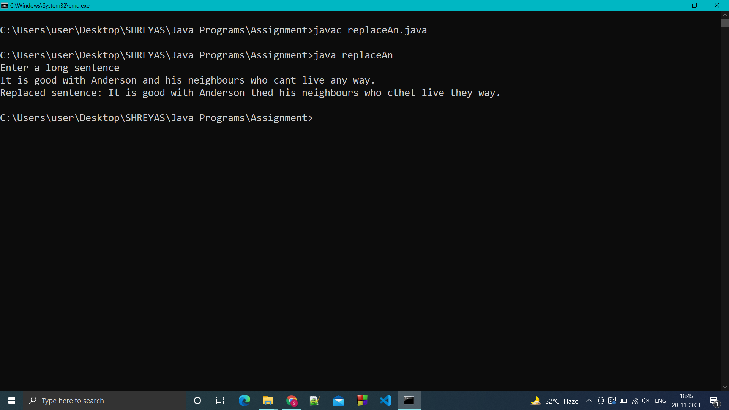

Q.8 Predict the output:

class A{

A()

{

System.out.println("A");

}

}

public class B extends A{

public static void main(String args[])

{

B b1=new B();

super();

}

B()

{

System.out.println("B");

}

}

Output:

Error: super() must be first statement of constructor

Q.9 Predict the output:

class MySuper

{

public  static void MyMethod()

{

System.out.println("Static  Method in super class");

}

}

public class Mysub extends Mysuper{

public static void MyMethod()

{

System.out.println("static method in subclass");

}

public void MyMethod()

{

System.out.println("Non-static method in subclass");

}

public static void main(String args[])

{

MySuper s=new MySub();

MyMethod();

}

}

OUPUT:

Error: Mysuper is not defined

Error: public void MyMethod()-> MyMethod() is already defined in class Mysub

Error: MySub is not defined

Q.10 Write a program to calculate volume of cube, cuboid and sphere using interfaces.

CODE:

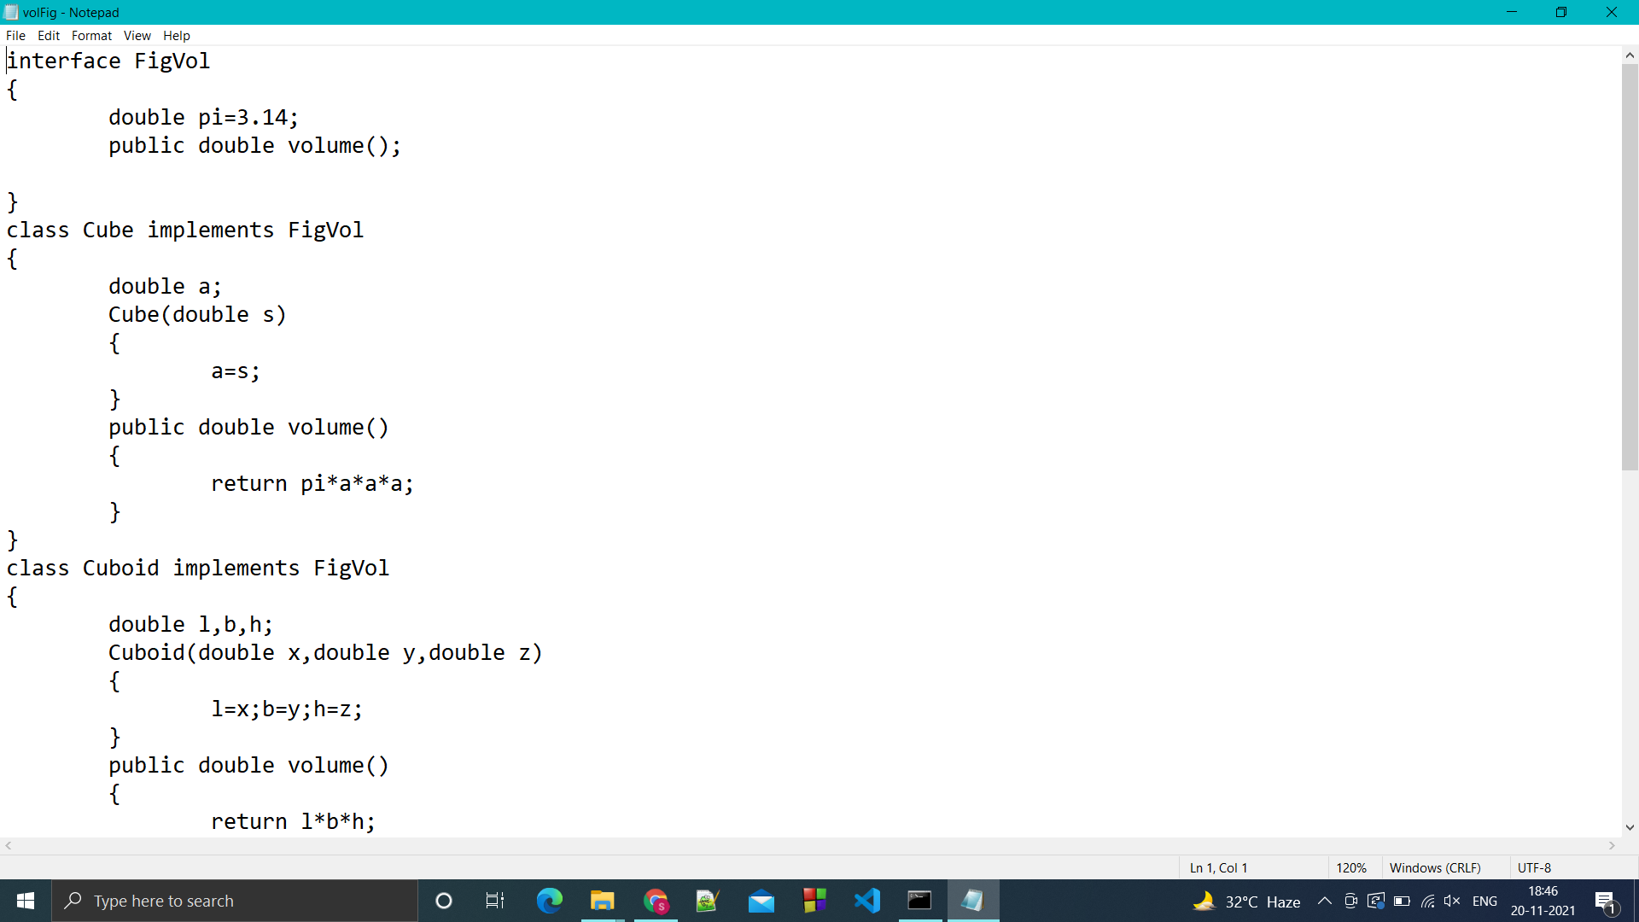

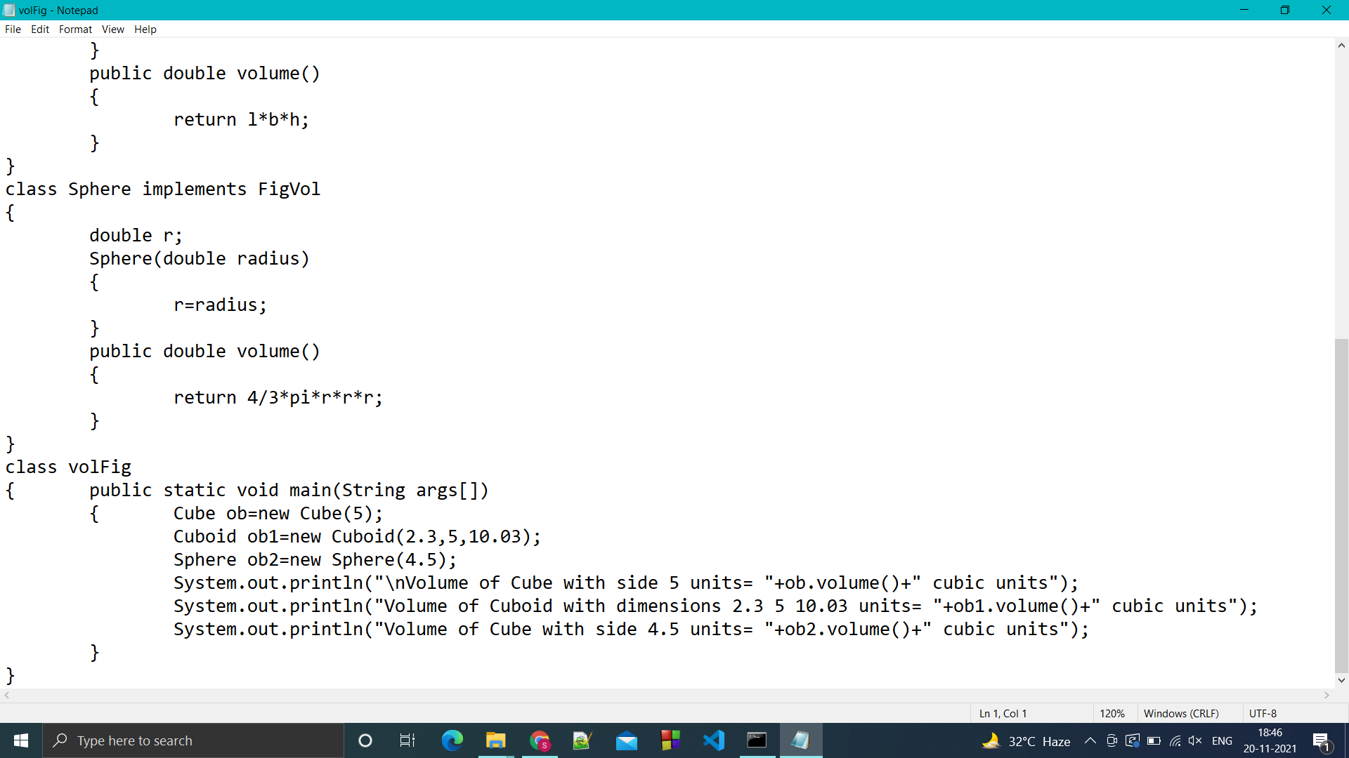

OUTPUT:

